**Whitewater Rafting Site Plan**

**Branding**

1. **Logo**



**Style Guide**

Color Schema  
 Color Palette URL: <https://coolors.co/palette/ffffff-00171f-003459-007ea7-00a8e8>

Primary-color: #FF9F1C

Secondary-color: #CBF3F0

Accent1-color: #FFBF69

Accent2-color: #2EC4B6

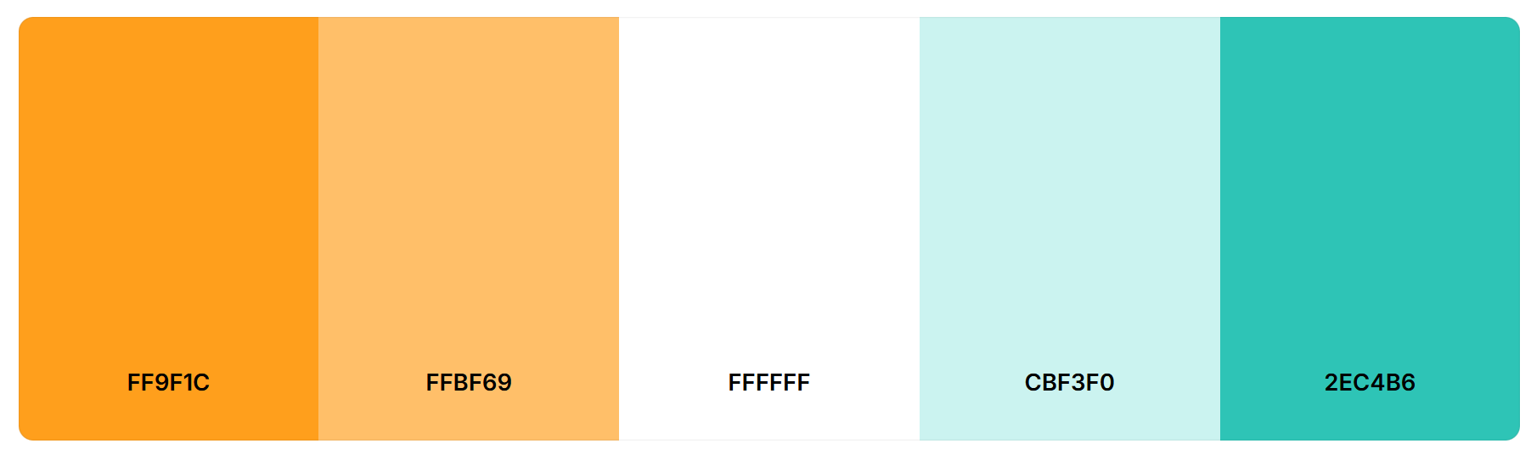

1. **Typography**

Heading-font: Montserrat SemiBold 600

Text-font: Figtree Regular 400